Drag and drop troubleshooting for MPLAB MPLABx IDE V5.40 and SAM-IOT

# Symptoms

Drag-and-dropping a *.hex firmware file into the “CURIOSITY” drive mounted by the SAM-IoT board causes an error and the board is not updated with the latest firmware.

# Explanation

This behavior occurs when the user programs the device using MPLAB V5.40.

MPLABX silently upgrade “Downgrade in reality” nEDBG debugger to default embedded firmware version 1.1.0.

This version does not support the drag and drop feature.

nEDBG firmware Version can be checked using either KIT-INFO.TXT file or atfw.exe tool (Studio package):

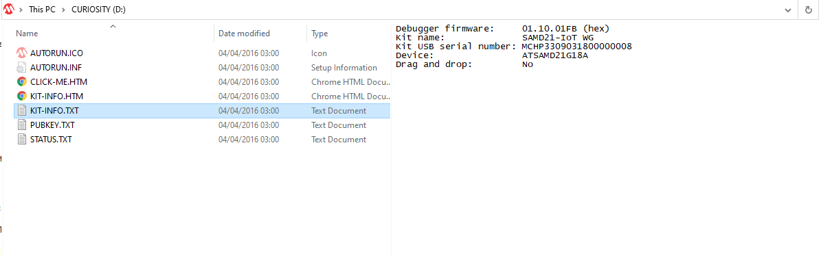

or

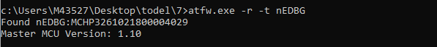

# Fix

The fix consists of updating MPLABx embedded nEDBG version to the latest one or at least the one supporting the SAM-IoT WG board.

This can be done using the tool packs tab as shown in the following.

Go to Tools->Packs and choose “Tool Packs”

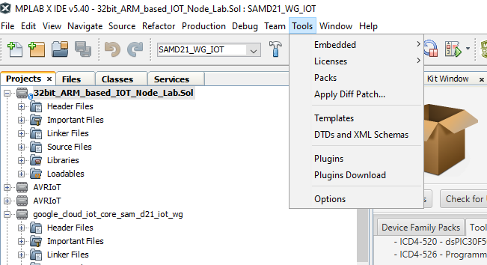

Locate the nEDBG_TP. Choose the latest firmware version or at least 1.3.164 version and click on update. This will install the new nEDBG firware which will be used instead of the MPLABX v5.40 default one.

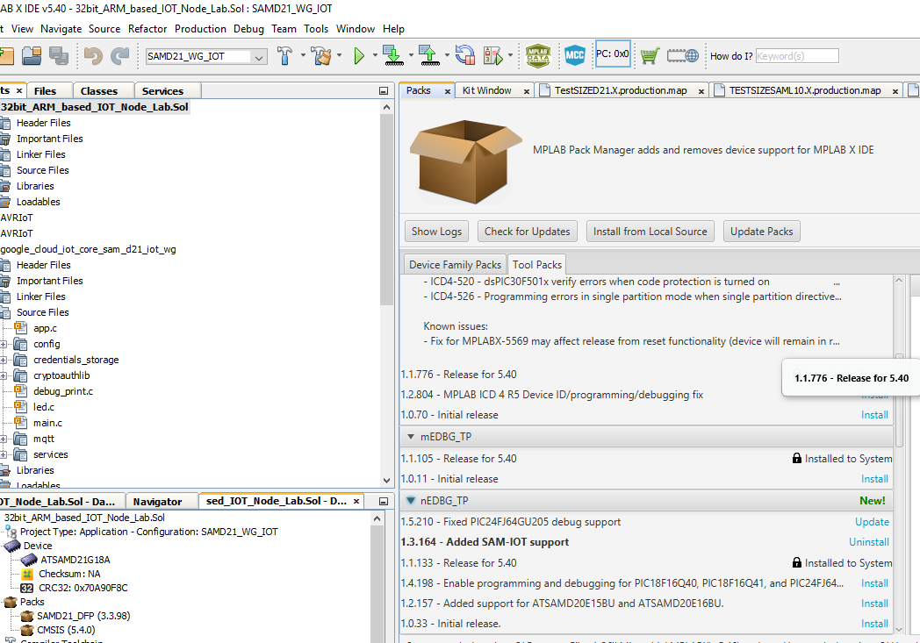

The next attempts to program the SAM-IoT WG board will result in nEDBG firmware being upgraded along with target firmware.

The drag and drop feature will be available again. The new version can be checked using KIT-INFO.TXT file or afw.exe tool

